**Project Report Template**

|  |  |  |
| --- | --- | --- |
|  | **Name** | **ID** |
| **Student 1:** | **Hassan Moubarak** | **108192** |
| **Student 2:** | **Abdulhadi Alhammak** | **108567** |

# Project Title

ArtConnect

# Project Description

ArtConnect is an online platform designed to bridge the gap between artists and their audience. It allows artists to showcase their artwork, while fans can engage through likes, comments, and follows. The platform aims to foster a vibrant community where creativity and appreciation coexist.

# Objective

* Provide artists with a user-friendly interface to upload and manage their artworks.
* Enable fans to discover, follow, and interact with their favorite artists.
* Facilitate meaningful interactions between artists and fans through comments and likes.
* Ensure a secure and seamless user experience for both artists and fans.

# Core Features

**User Registration and Login:**

**Secure user authentication.**

**Ability to create personalized accounts.**

**Image Upload:**

* Users can upload their artwork.

**Liking and Commenting:**

* Users can like and comment on posts to engage with others' artwork.

**Following System:**

* Users can follow and unfollow other artists to build connections.

**Profile Pages:**

* Each user has a profile displaying their posts, follower count, and following count.

**Feed:**

* A personalized feed showing posts from followed users.

**Responsive Design:**

* Accessible across devices (desktop, tablet, mobile).

# Database Design

* Users: To store information about artists and fans
* Posts: To store artwork details, artwork and likes and captions if available
* Images: To store the image and artist
* Likes: To keep track of which users liked which artworks
* Comments: For user comments on artworks
* Followers: To track relationships between users

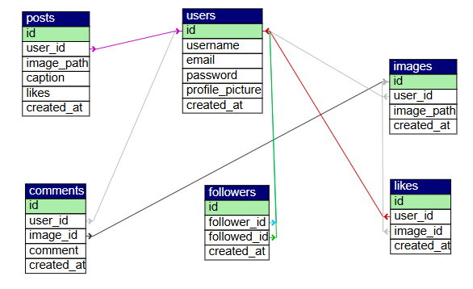

# ~~Models and Migrations (If using Laravel)~~

* **Models**: Describe each model in your system and how it corresponds to your database tables. Indicate the relationships between the models (e.g., users and posts).
* **Migrations**: Specify what migrations will be needed to create the database tables and any constraints (e.g., foreign keys, nullable fields).

# Frontend Overview

**Technologies:**

* HTML, CSS, and JavaScript.

**Key Views:**

* **Login/Sign up Page:** User login to see recent work from followed artists and see profile
* **User Dashboard:** Shows posts from followed artists, and a section to follow other artists.
* **Profile Page:** View artwork, comments, likes, etc.
* **Button/Form: To upload artwork**

# Backend Overview

**Core Logic:**

* Implemented in PHP to handle user authentication, post uploads, likes, and comments.
* Business logic in server-side PHP scripts processes requests and responds with dynamic content.

**Middleware and Security:**

* Middleware for authentication and input validation.
* Hashing passwords for secure storage

# Form Handling & Validation

**Forms:**

* **Registration Form:** Collect user information securely.
* **Login Form:** Handle user authentication.
* **Artwork Upload Form:** Enable artists to upload image files and metadata.

**Validation:**

* Used PHP’s built-in validation for checking inputs (e.g., ensuring fields are not empty, valid email formats, file size constraints, etc.).
* Sanitized inputs to prevent SQL injection or XSS attacks.

# Roles and Permissions

* **Currently, the project focuses on a single user role (artists and fans). Additional roles such as Admins can be introduced later for moderation.**

# Challenges

* **Data Validation:** Ensuring all user inputs are validated to prevent SQL injection and other security threats.
* **File Handling:** Managing image uploads and storage efficiently without compromising server performance.
* **User Experience:** Designing an intuitive interface that caters to both tech-savvy and non-tech-savvy users.

# Timeline

* Week 1-2: Research and planning.
* Define project scope.
* Design database schema.
* Week 3-4: Backend development.
* Implement user registration, login, and database connections.
* Develop image upload and post management functionality.
* Week 5: Frontend development.
* Build forms for uploading, liking, and commenting.
* Create user profiles and feeds.
* Week 6: Testing and final debugging.
* Test like, comment, and follow features.
* Deploy the project and prepare documentation.